**ELECTRICAL CIRCUITS**

**LECTURE NOTES - B.TECH**

**(I YEAR – II SEM)**

**(2022-23)**

**EEE-A**

# Department of Electrical and Electronics Engineering

**Subject: CIRCUITS& NETWORKS**

**UNIT-I**

**NETWORK THEOREMS**

* **Superposition Theorem**

# Reciprocity Theorem

# Thevenin’s Theorem

* **Norton’s Theorem**

# Maximum Power Transfer Theorem

INTRODUCTION:

Any complicated network i.e. several sources, multiple resistors are present if the single element response is desired then use the network theorems. Network theorems are also can be termed as network reduction techniques. Each and every theorem got its importance of solving network. Let us see some important theorems with DC and AC excitation with detailed procedures.

Superposition Theorem:

The principle of superposition helps us to analyze a linear circuit with more than one current or voltage sources sometimes it is easier to find out the voltage across or current in a branch of the circuit by considering the effect of one source at a time by replacing the other sources with their ideal internal resistances.

Superposition Theorem Statement:

Any linear, bilateral two terminal network consisting of more than one sources, The total current or voltage in any part of a network is equal to the algebraic sum of the currents or voltages in the required branch with each source acting individually while other sources are replaced by their ideal internal resistances. (i.e. Voltage sources by a short circuit and current sources by open circuit)

Steps to Apply Super position Principle:

1. Replace all independent sources with their internal resistances except one source. Find the output (voltage or current) due to that active source using nodal or mesh analysis.
2. Repeat step 1 for each of the other independent sources.
3. Find the total contribution by adding algebraically all the contributions due to the independent sources.

Example: By Using the superposition theorem find I in the circuit shown in figure?

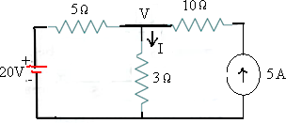

Fig.(a)

**Solution:** Applying the superposition theorem, the current **I2** in the resistance of 3 Ω due to the voltage source of 20V alone, with current source of 5A open circuited [ as shown in the figure.1 below ] is given by :

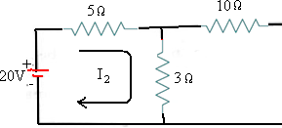

Fig1

I2 = 20/(5+3) = 2.5A

Similarly the current I5 in the resistance of 3 Ω due to the current source of 5A alone with voltage source of 20V short circuited [ as shown in the figure.2 below ] is given by :

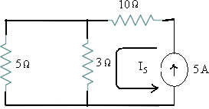

Fig.2

I5= 5 x 5/(3+5) = 3.125 A

The total current passing through the resistance of 3Ω is then = I2 + I5= 2.5 + 3.125 = **5.625 A**

Let us verify the solution using the basic nodal analysis referring to the node marked with V in fig.(a).Then we get :

𝑉 − 20 𝑉

5 + 3 = 5

3V-60+5V=15× 5

8V-60=75

8V=135 V=16.875

The current I passing through the resistance of 3Ω =V/3 = 16.875/3 = 5.625 A .

**Reciprocity theorem:**

Under Basic Electrical Engineering In many electrical networks it is found that if the positions of voltage source and ammeter are interchanged, the reading of ammeter remains the same. Suppose a voltage source is connected to a passive network and an ammeter is connected to other part of the network to indicate the response. Now any one interchanges the positions of ammeter and voltage source that means he or she connects the voltage source at the part of the network where the ammeter was connected and connects ammeter to that part of the network where the voltage source was connected. The response of the ammeter means current through the ammeter would be the same in both the cases. This is where the property of reciprocity comes in the circuit. The particular circuit that has this reciprocal property, is called reciprocal circuit.

Reciprocity theorem Statement:

Any linear, bilateral two terminal network the ratio of excitation to response is constant even though the source is interchanged from input terminals to the output terminals.

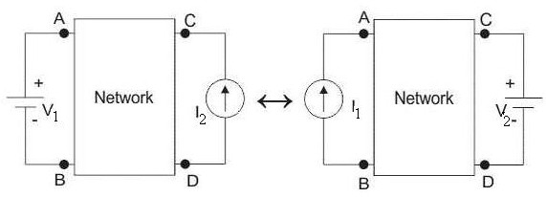

𝑉1

𝐼2

𝑉2

##### =

𝐼1

Steps For Solution Of a Network Utilizing Reciprocity Theorem:

1. The branches between which reciprocity is to be established to be selected first.
2. The current in the branch is obtained using conventional network analysis.
3. The voltage source is interchanged between the branches concerned.
4. The current in the branch where the voltage source was existing earlier is calculated. It may observe that the currents obtained in 2 & 4 are identical to each other.

Example: Verify the reciprocity theorem for the network shown in the figure (1).?

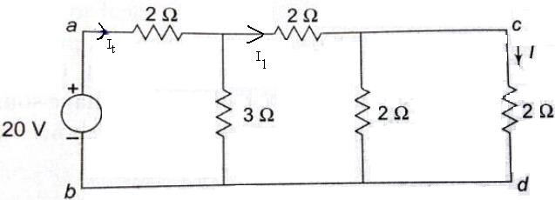

Fig.(1)

**Solution:** Total resistance in the circuit across the applied voltage of 20 V is RTH=2 + [3||(2 +( 2||2))]

=2 +[3||3]

=3.5 Ω

The total current drawn by the circuit **IT =** 𝑽 **=** 20/3.5 **=** 5.71 A

𝑹𝑻𝑯

The current **I** in the branch ‘**cd’** with 2 Ω resistance is find by using current division rule. For that first find I1 current.

I =5.71× 3 =2.855A

1

3+3

The current I in the ‘cd’ branch is

I=2.855× 2 =1.427A

2+2

Now the source voltage and the response are interchanged between branches ‘**ab’** and ‘**cd’** as shown in the figure (2) below

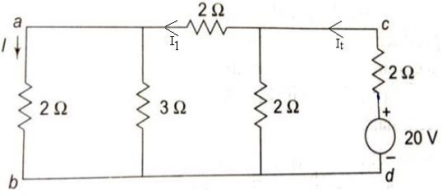.

Fig.(2)

Total resistance in the circuit across the applied voltage of 20 V is RTH=2 + [2||(2 +( 2||3))]

=2 +[2||3.2]

=3.23Ω

The total current drawn by the circuit **IT =** 𝑽 **=**20/3.23**=**6.19A

𝑹𝑻𝑯

The current **I** in the branch ‘**ab’** with 2 Ω resistance is find by using current division rule. For that first find I1 current.

I =6.19× 2 =2.38A

1

3.2+2

The current I in the ‘ab’ branch is

I=2.38× 3 =1.427A

3+2

The current in the branch ‘**ab’ = 1.427 A** which is same as the current we got in branch ‘**cd’** when the voltage was given from branch ‘**ab’ .** Thus the **reciprocity theorem** is verified.

.

Thevenin’s Theorem and Norton’s theorem (Introduction) :

Thevenin’s Theorem and Norton’s theorem are two important theorems in solving Network problems having many active and passive elements. Using these theorems the networks can be reduced to simple equivalent circuits with one active source and one element. In circuit analysis many a times the current through a branch is required to be found when it’s value is changed with all other element values remaining same. In such cases finding out every time the branch current using the conventional mesh and node analysis methods is quite awkward and time consuming. But with the simple equivalent circuits (with one active source and one element) obtained using these two theorems the calculations become very simple. Thevenin’s and Norton’s theorems are dual theorems.

Thevenin’s Theorem Statement :

Any linear, bilateral two terminal network consisting of sources and resistors(Impedance),can be replaced by an equivalent circuit consisting of a voltage source in series with a resistance (Impedance).The equivalent voltage source **VTh** is the open circuit voltage looking into the terminals(with concerned branch element removed) and the equivalent resistance **RTh** while all sources are replaced by their internal resistors at ideal condition i.e. voltage source is short circuit and current source is open circuit.

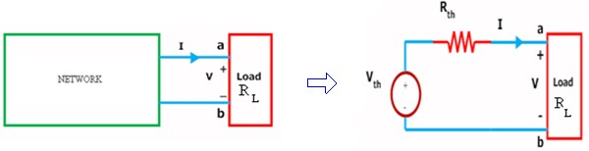

1. (b)

Figure (a) shows a simple block representation of a network with several active / passive elements with the load resistance **RL** connected across the terminals **‘a & b’** and figure (b) shows the **Thevenin equivalent circuit** with **VTh** connected across **RTh** & **RL .**

Main steps to find out VTh and RTh :

1. The terminals of the branch/element through which the current is to be found out are marked as say **a & b** after removing the concerned branch/element.
2. Open circuit voltage **VOC** across these two terminals is found out using the conventional network mesh/node analysis methods and this would be **VTh .**
3. **Thevenin resistance RTh** is found out by the method depending upon whether the network contains dependent sources or not.
   1. With dependent sources: **RTh = Voc / Isc**
   2. Without dependent sources : **RTh = Equivalent resistance looking into the concerned terminals** with all voltage & current sources replaced by their internal impedances (i.e. ideal voltage sources short circuited and ideal current sources open circuited)
4. Replace the network with **VTh** in series with **RTh** and the concerned branch resistance **(or)**

load resistance across the load terminals(A&B) as shown in below fig.

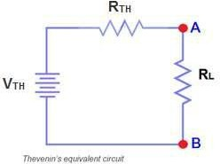

**Example: Find VTH, RTH and the load current and load voltage flowing through RL resistor as shown in fig. by using Thevenin’s Theorem?**

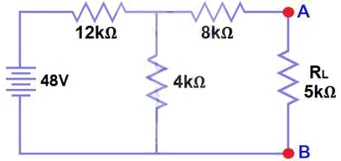

Fig.(a)

Solution:

The resistance **RL** is removed and the terminals of the resistance **RL** are marked as **A & B** as shown in the fig. (1)

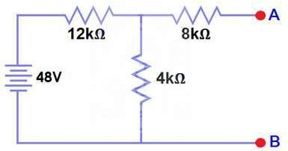

Fig.(1)

Calculate / measure the Open Circuit Voltage. This is the Thevenin Voltage (VTH). We have already removed the load resistor from fig.(a), so the circuit became an open circuit as shown in fig (1). Now we have to calculate the Thevenin’s Voltage. Since 3mA Current flows in both 12kΩ and 4kΩ resistors as this is a series circuit because current will not flow in the 8kΩ resistor as it is open. So 12V (3mA x 4kΩ) will appear across the 4kΩ resistor. We also know that current is not flowing through the 8kΩ resistor as it is open circuit, but the 8kΩ resistor is in parallel with 4k resistor. So the same voltage (i.e. 12V) will appear across the 8kΩ resistor as

4kΩ resistor. Therefore 12V will appear across the AB terminals. So,**VTH = 12V**

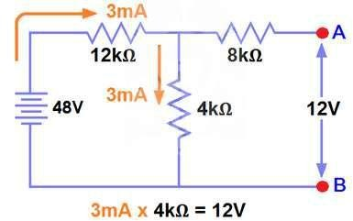

Fig(2)

All voltage & current sources replaced by their internal impedances (i.e. ideal voltage sources short circuited and ideal current sources open circuited) as shown in fig.(3)

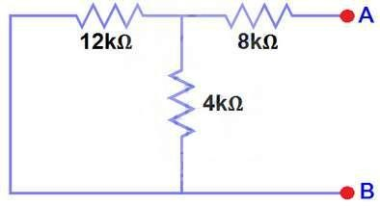

Fig(3)

Calculate /measure the Open Circuit Resistance. This is the Thevenin Resistance (RTH)We have Reduced the 48V DC source to zero is equivalent to replace it with a short circuit as shown in figure (3) We can see that 8kΩ resistor is in series with a parallel connection of 4kΩ resistor and 12k Ω resistor. i.e.:

8kΩ + (4k Ω || 12kΩ) ….. (|| = in parallel with) RTH = 8kΩ + [(4kΩ x 12kΩ) / (4kΩ + 12kΩ)] RTH = 8kΩ + 3kΩ

**RTH = 11kΩ**

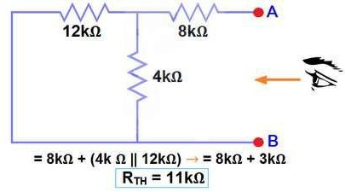

Fig(4)

Connect the RTH in series with Voltage Source VTH and re-connect the load resistor across the load terminals(A&B) as shown in fig (5) i.e. Thevenin circuit with load resistor. This is the Thevenin’s equivalent circuit

RTH

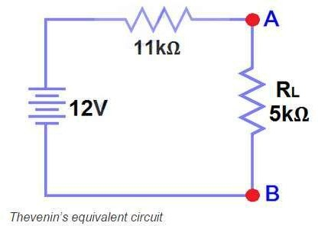

VTH

Fig(5)

Now apply Ohm’s law and calculate the total load current from fig 5. IL = VTH/ (RTH + RL)= 12V / (11kΩ + 5kΩ) = 12/16kΩ

**IL= 0.75mA**

And VL = ILx RL= 0.75mA x 5kΩ

**VL= 3.75V**

**Norton’s Theorem Statement :**

Any linear, bilateral two terminal network consisting of sources and resistors(Impedance),can be replaced by an equivalent circuit consisting of a current source in parallel with a resistance (Impedance),the current source being the short circuited current across the load terminals and the resistance being the internal resistance of the source network looking through the open circuited load terminals.

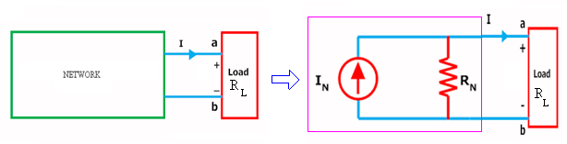

(a) (b)

Figure (a) shows a simple block representation of a network with several active / passive elements with the load resistance **RL** connected across the terminals **‘a & b’** and figure (b) shows the **Norton equivalent circuit** with **IN** connected across **RN** & **RL .**

Main steps to find out IN and RN:

1. The terminals of the branch/element through which the current is to be found out are marked as say **a & b** after removing the concerned branch/element.
2. Open circuit voltage **VOC** across these two terminals and **ISC** through these two terminals are found out using the conventional network mesh/node analysis methods and they are same as what we obtained in Thevenin’s equivalent circuit**.**
3. Next **Norton resistance RN** is found out depending upon whether the network contains dependent sources or not.
   1. With dependent sources: **RN = Voc / Isc**
   2. Without dependent sources : **RN =** Equivalent resistance looking into the concerned terminals with all voltage & current sources replaced by their internal impedances (i.e. ideal voltage sources short circuited and ideal current sources open circuited)
4. Replace the network with **IN** in parallel with **RN** and the concerned branch resistance across the load terminals(A&B) as shown in below fig

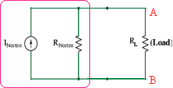

**Example: Find the current through the resistance RL (1.5 Ω) of the circuit shown in the figure (a) below using Norton’s equivalent circuit.?**

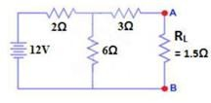

Fig(a)

**Solution:** To find out the Norton’s equivalent ckt we have to find out **IN** = **Isc ,RN=Voc**/ **Isc.**

Short the 1.5Ω load resistor as shown in (Fig 2), and Calculate / measure the Short Circuit Current. This is the Norton Current (IN).

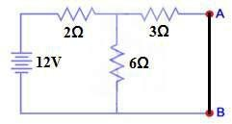

Fig(2)

We have shorted the AB terminals to determine the Norton current, IN. The 6Ω and 3Ω are then in parallel and this parallel combination of 6Ω and 3Ω are then in series with 2Ω.So the Total Resistance of the circuit to the Source is:-

2Ω + (6Ω || 3Ω) ….. (|| = in parallel with) RT = 2Ω + [(3Ω x 6Ω) / (3Ω + 6Ω)]

RT = 2Ω + 2Ω

RT = 4Ω IT = V / RT

IT = 12V / 4Ω= 3A..

Now we have to find ISC = IN… Apply CDR… (Current Divider Rule)… ISC = IN = 3A x [(6Ω / (3Ω + 6Ω)] = 2A.

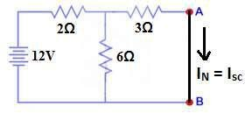**ISC= IN = 2A.**

Fig(3)

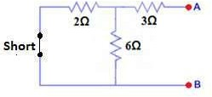All voltage & current sources replaced by their internal impedances (i.e. ideal voltage sources short circuited and ideal current sources open circuited) and Open Load Resistor. as shown in fig.(4)

Fig(4)

Calculate /measure the Open Circuit Resistance. This is the Norton Resistance (RN) We have Reduced the 12V DC source to zero is equivalent to replace it with a short circuit as shown in fig(4), We can see that 3Ω resistor is in series with a parallel combination of 6Ω resistor and 2Ω resistor. i.e.:

3Ω + (6Ω || 2Ω) ….. (|| = in parallel with) RN = 3Ω + [(6Ω x 2Ω) / (6Ω + 2Ω)]

RN = 3Ω + 1.5Ω

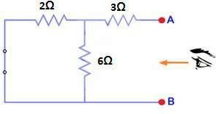**RN = 4.5Ω**

Fig(5)

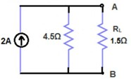Connect the RN in Parallel with Current Source IN and re-connect the load resistor. This is shown in fig (6) i.e. Norton Equivalent circuit with load resistor.

Fig(6)

Now apply the Ohm’s Law and calculate the load current through Load resistance across the terminals A&B. Load Current through Load Resistor is

IL = IN x [RN / (RN+ RL)]

IL= 2A x (4.5Ω /4.5Ω +1.5kΩ) IL = 1.5A **IL = 1. 5A**

Maximum Power Transfer Theorem:

In many practical situations, a circuit is designed to provide power to a load. While for electric utilities, minimizing power losses in the process of transmission and distribution is critical for Efficiency and economic reasons, there are other applications in areas such as communications where it is desirable to maximize the power delivered to a load. electrical applications with electrical loads such as Loud speakers, antennas, motors etc. it would be required to find out the condition under which maximum power would be transferred from the circuit to the load.

Maximum Power Transfer Theorem Statement:

Any linear, bilateral two terminal network consisting of a resistance load, being connected to a dc network, receives maximum power when the load resistance is equal to the internal resistance (Thevenin’s equivalent resistance) of the source network as seen from the load terminals.

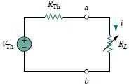

According to Maximum Power Transfer Theorem, for maximum power transfer from the network to the load resistance , **RL** must be equal to the source resistance i.e. Network’s Thevenin equivalent resistance **RTh . i.e. RL = RTh**

The load current **I** in the circuit shown above is given by,

𝐼 = 𝑉𝑇𝐻

𝑅𝑇𝐻+𝑅𝐿

The power delivered by the circuit to the load:

𝑃 = 𝐼2𝑅 =

2

𝑇𝐻

𝑉

(𝑅𝑇𝐻+𝑅𝐿)2

𝑅𝐿

The condition for maximum power transfer can be obtained by differentiating the above expression for power delivered with respect to the load resistance (Since we want to find out the value of **RL** for maximum power transfer) and equating it to zero as :

𝜕𝑃

= 0 =

2

𝑇𝐻

𝑉

−

2

2

𝑇𝐻

2𝑉

##### 3 𝑅𝐿 = 0

𝜕𝑅𝐿

(𝑅𝑇𝐻+𝑅𝐿)

(𝑅𝑇𝐻+𝑅𝐿)

Simplifying the above equation, we get:

(𝑅𝑇𝐻 + 𝑅𝐿) − 2𝑅𝐿 = 0 ⟹ 𝑅𝐿 = 𝑅𝑇𝐻

Under the condition of maximum power transfer, the power delivered to the load is given by :

𝑉2 𝑉2

𝑃𝑀𝐴𝑋 = 𝑇𝐻 × 𝑅𝐿= 𝑇𝐻

(𝑅𝐿+𝑅𝐿)2

4𝑅𝐿

Under the condition of maximum power transfer, the efficiency 𝜼 of the network is then given by:

𝑉2 𝑉2

𝑃𝐿𝑂𝑆𝑆 = 𝑇𝐻 × 𝑅𝑇𝐻= 𝑇𝐻

(𝑅𝐿+𝑅𝐿)2

output

𝜼 = =

𝑉

2

𝑇𝐻

𝑉

##### 4𝑅𝐿

4𝑅𝐿

= 0.50

𝑉

input

2

( 𝑇𝐻 + 4𝑅𝐿

2

𝑇𝐻)

##### 4𝑅𝐿

For maximum power transfer the load resistance should be equal to the Thevenin equivalent resistance ( or Norton equivalent resistance) of the network to which it is connected . Under the condition of maximum power transfer the efficiency of the system is 50 %.

Example: Find the value of RL for maximum power transfer in the circuit of Fig. Find the maximum power.?

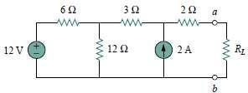

**Solution:**We need to find the Thevenin resistance *R*Th and the Thevenin voltage *V*Th across the terminals *a*-*b*. To get *R*Th, we use the circuit in Fig. (a)

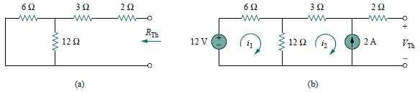

RTh= 2 + 3 + (6 // 12 )=5+(6×12)=5+4=9Ω

6+12

To get *V*Th, we consider the circuit in Fig.(b).Applying mesh analysis,

−12 + 18i1− 12i2 = 0*,* i2 = −2 A,

Solving for i1, we get i1= −2*/*3.

Applying KVL around the outer loop to get *V*Th across terminals *a*-*b*, we obtain,

−12 + 6i1+ 3i2+ 2(0) + VTh= 0

VTh= 22 V

For maximum power transfer, *RL*= *R*Th= 9Ω and the maximum power is,

2

𝑉

𝑃𝑀𝐴𝑋 = 𝑇𝐻=

4𝑅𝐿

22×22

4×9

=13.44W